**Portfolio link:**

My Portfolio link: <https://mohamedabisheik-deveolper.web.app/>

**UI Screenshots:**

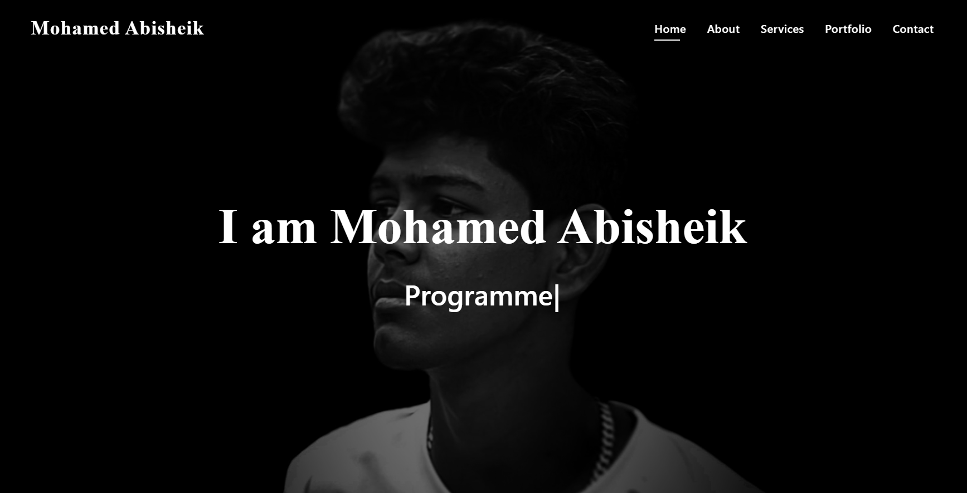

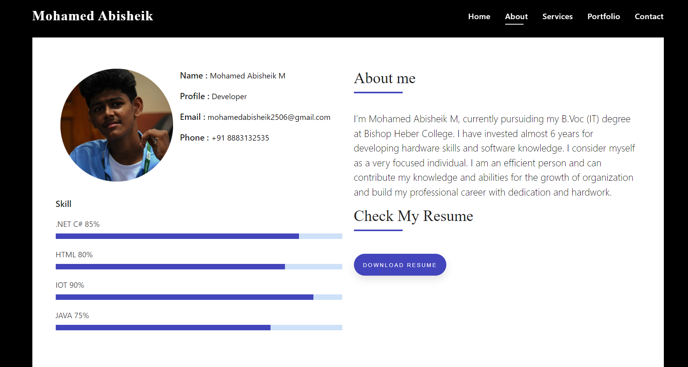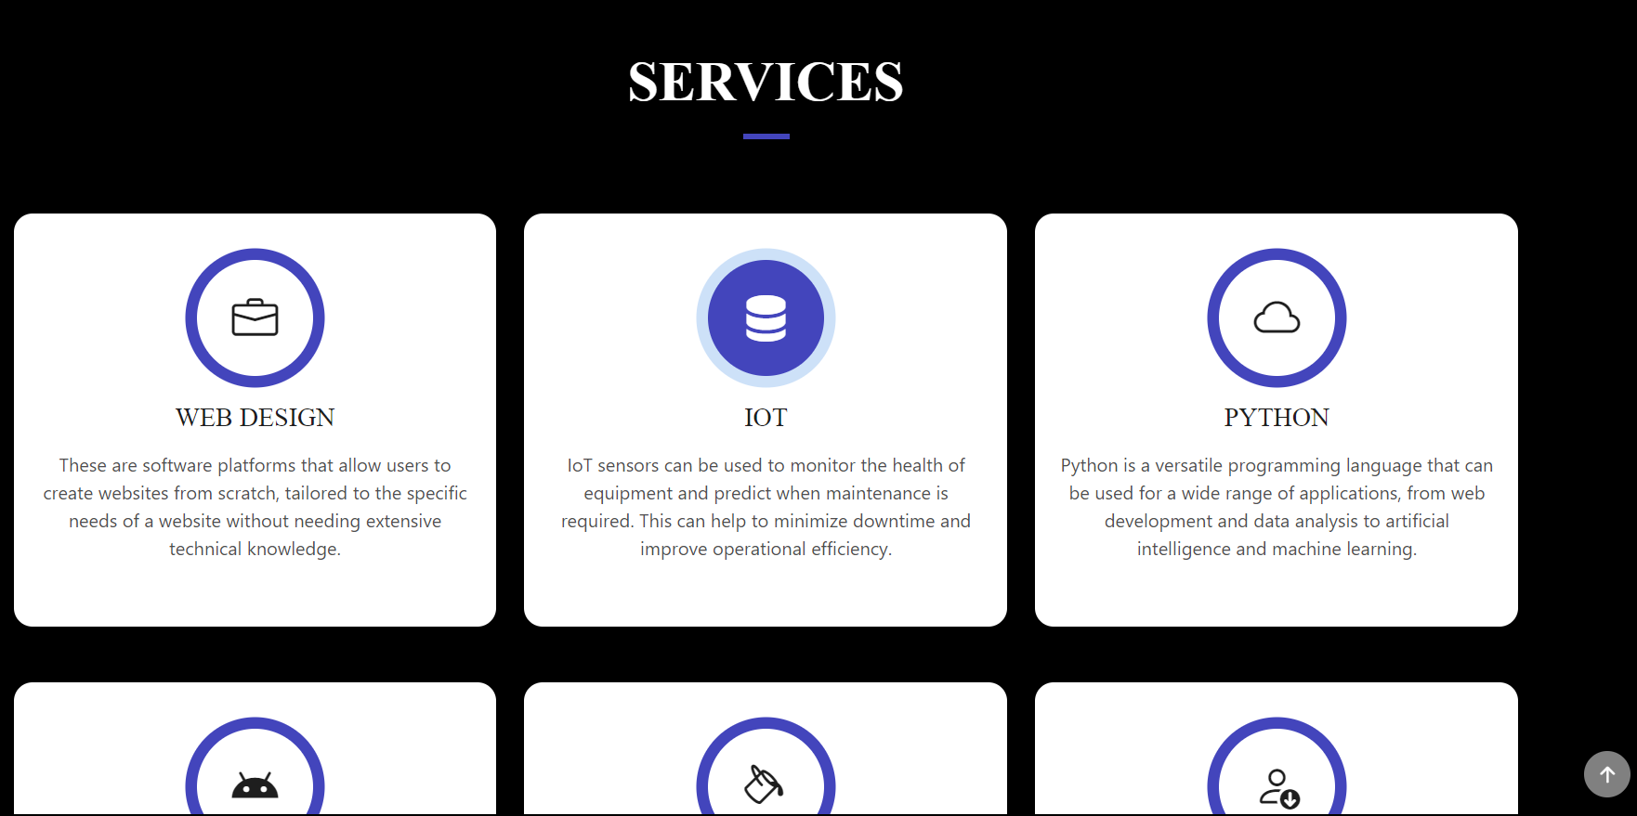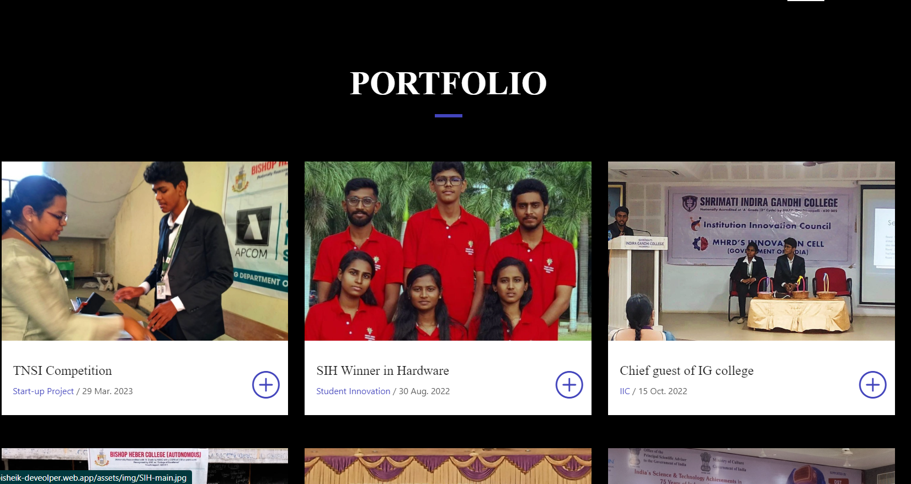

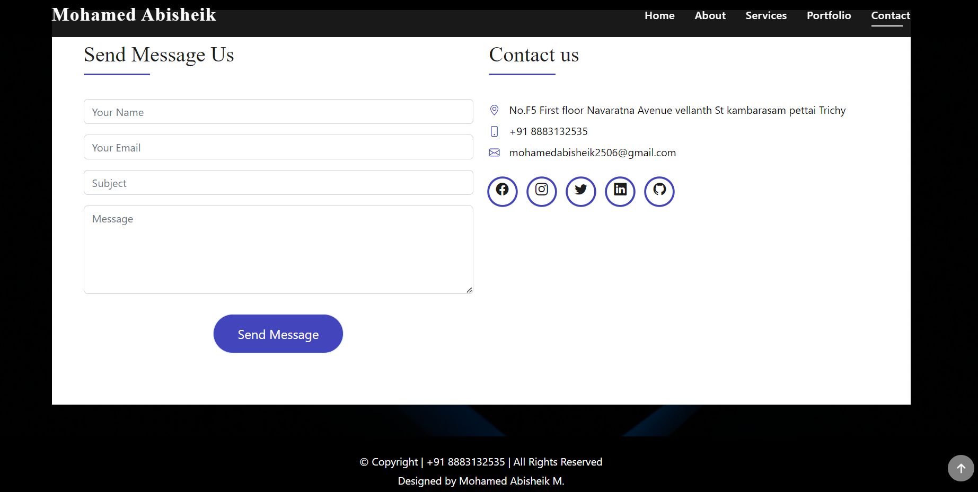

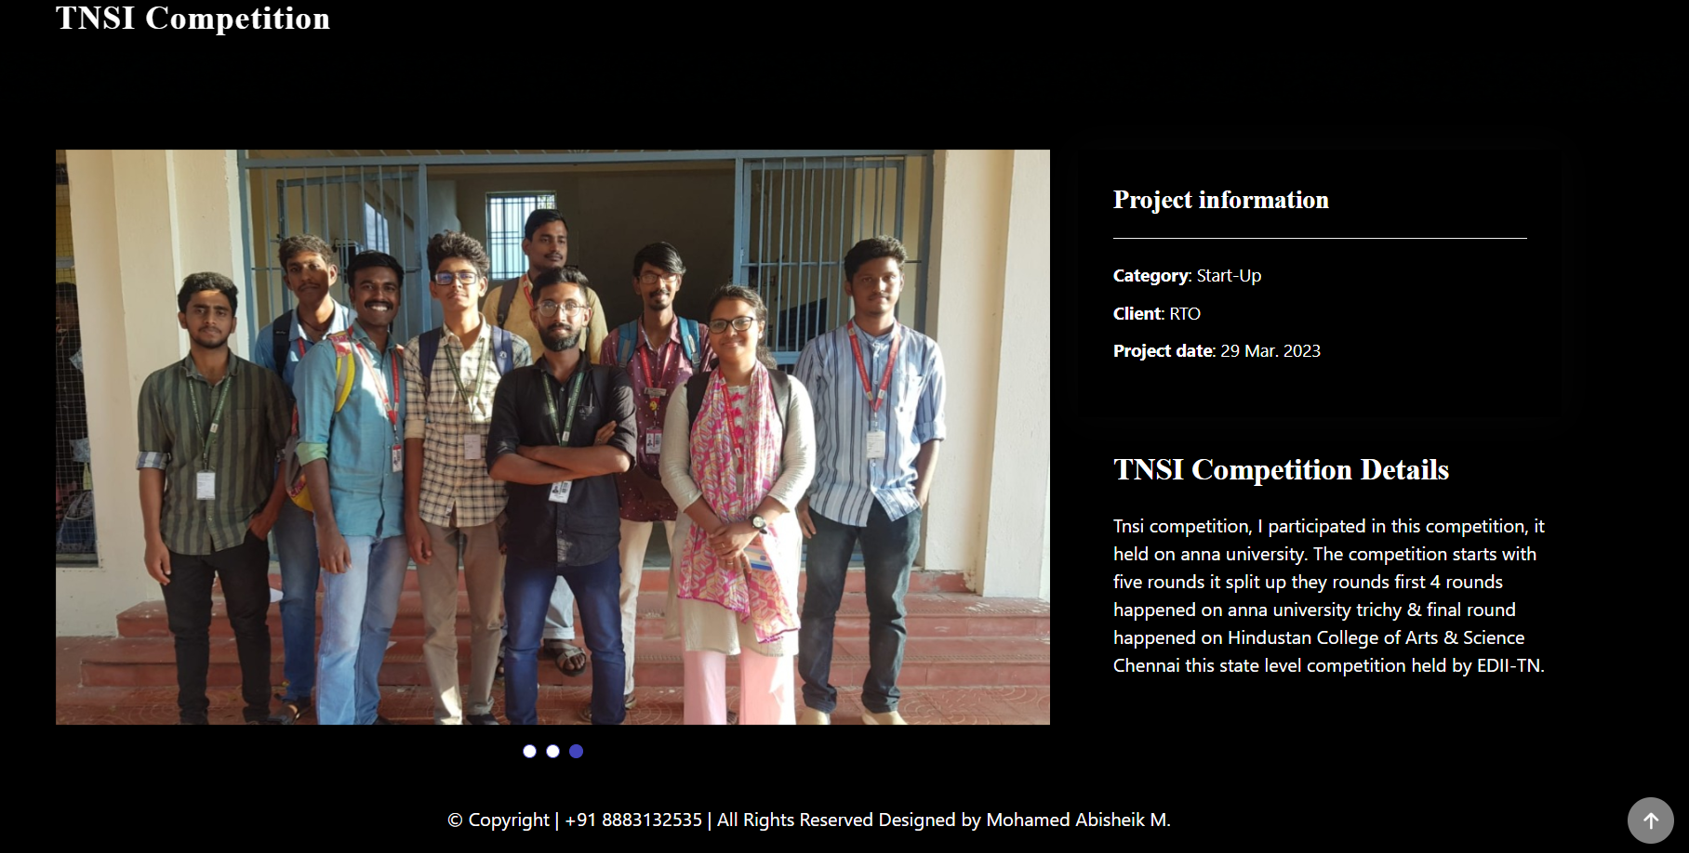

HTML/CSS/JS/PHP Code:

<https://drive.google.com/drive/folders/1J_VAoUana6D0sakoh8X9CpNO2itNdf7D?usp=drive_link>